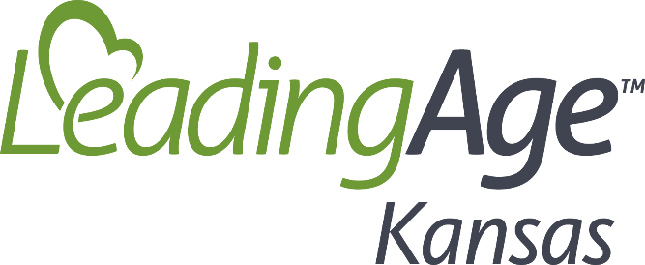

Request for Presentations Example Topics
Keep in mind all presentations are intended to be educational in nature. Presenters may not sell or promote any specific product, company or service.
Audience: The audience for educational sessions include professionals from Nursing Home, Assisted Living/Adult Care Facility, Adult Day Health Care, Continuing Care Retirement Community, PACE/Managed Long Term Care, Home Care, Hospice, and other Senior Services providers. Sessions that are applicable to one or more of the service types are welcomed.
Topic Ideas: These are just topic ideas. Your topic does NOT have to be from this list to be considered.
Workforce:
- Recruitment and Retention – Best practices and solutions
- Communicating with a diverse workforce
- Creating more flexibility and autonomy for workers
- Achieving Efficiencies in staffing while maintaining quality and compliance.
- Technologies to assist and support an overstretched workforce
- Using public relations to elevate the image of the field for recruitment
- Employment of foreign-born workers
- Community, regional and state partnerships for finding, preparing and retaining workers
- Employee wellness or assistance programs
- Combatting burnout
- Team building
- Conflict resolution
Serving Residents/Clients
- Honoring autonomy while protecting safety and ensuring compliance
- Person-centered care for individuals with diminished capacity
- Person-centered service planning across the continuum
- Visioning services for future residents/clients
- Serving adults with mental health and substance abuse diagnoses
  - Treatment models
  - Mitigating liability and safety risks
  - Reimbursement challenges
  - Planning for the future customer

Program and Facilities Operations
- Legal or Regulatory updates
- Electronic Health Information Exchange to Support Care Coordination, Improved Outcomes, and Alternative Payment Models
- Immigration policy and the impact on workforce
- Cyber security
- Getting psychosocial programming back on track and better than ever
- Electronic health information exchange to support care coordination and improved outcomes
- Potential implications of marijuana and CBD products use
- Effective communication in times of stress
Quality and Oversight
- RoP and Survey updates – what trends are being found
- Risk management
- Psychotropic reduction
- Life safety code updates
- Infection Prevention
Finances/Reimbursement
- PDPM- how to be successful
- Managing during financial challenges
- Medicare managed care for assisted living
- HCBS and Medicare Advantage
- Home health value-based purchasing
Other
- Using collaboration to provide the right services and improve the bottom line
- Telehealth opportunities
- New models for HCBS
- New technologies

